
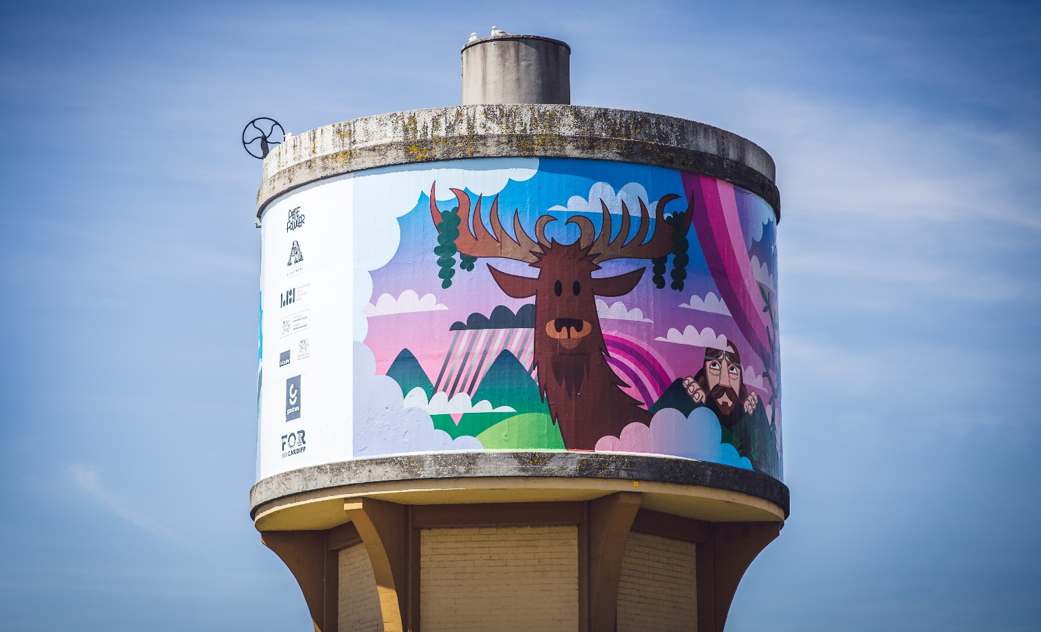
Image: Pete Fowler’s mural on the Great Western Water Tower, Cardiff
Deputy CEO & Head of Operations
Permanent, Full-time
Salary: £40,000 per annum
Location: Wales (position is currently remote working).
Main offices are usually located in Cardiff and Llanystumdwy
Closing Date: Monday 12 April, 5.00 pm Interviews: Thursday 15 April 2021

Literature Wales, the national company for the development of literature, is recruiting for the role of Deputy CEO & Head of Operations.
Are you an imaginative and analytical thinker who likes to drive change and question established systems of working? Are you committed to values of inclusion and fairness, and do you believe that culture in all its forms can bring about positive change to society? Can you help lead a team of people and embrace the challenges of a post-covid recovery process for the arts?
If so, then you might want to consider applying for this exciting role, which is a key leadership position in one of Wales’ foremost arts organisations. You could be looking for a new challenge and a step up from your current role, or you might be seeking an opportunity to work in a different setting and sector.
We are not necessarily looking for somebody with a background in arts and literature. What is more important is a positive attitude towards change and challenge, the potential to lead and inspire people, and a belief in the values and ambitions of the organisation.
A day in the life of the Deputy CEO & Head of Operations
Your working day is varied and often requires reprioritisation as urgent tasks land. You will find yourself liaising with colleagues and partners while preparing a large grant application, making sure the proposal delivers against the strategic aims of our stakeholders.
There is a regular cycle of Management Board meetings which require reporting, and part of your responsibility will involve checking compliance, overseeing the risk register, and updating Directors on progress towards mitigating the highest risks identified. You will also coordinate the policy updates provided by your colleagues, and lead on some of the more complex and current policies, for example a Sustainability Policy.
You will regularly liaise with representatives from the Arts Council of Wales, aligning organisational targets with key policy areas, including the seven goals of the Well-being of Future Generations Act. You will also work through past reports, building the business model to make the most of opportunities in a post COVID-19 climate.
On other days you will meet with stakeholders from across the health, tourism, arts, education, third and heritage sectors, building relationships and working on joint initiatives which are innovative and deliver for the wider literature sector. You will run several creative projects alongside those you develop and hand over to others to deliver.
Your project management work will involve hands on budget management and artist liaison, monitoring and evaluation, and communications. Across your working week you will get stuck in as part of the team and this involves proactively initiating solutions, doing your own administration and having an open attitude to learning from all colleagues.
About the role
A strategic thinker who is passionate about change and resilience, you will be responsible for leading the business planning and operational side of the organisation.
Within this role, you will support the CEO in managing and implementing internal systems and structures, including risk management, compliance, and fundraising. You will manage a small team of officers responsible for finance, monitoring and evaluation, and governance, as well as supporting the CEO in managing members of the Senior Leadership Team
You will be able to demonstrate how the strategic and creative direction of the organisation helps to support many of the Welsh Government’s key objectives, including: the Cultural Contract; The Well-being of Future Generations (Wales) Act 2015; Cymraeg 2050; the 2022 Curriculum for Wales; and the International Strategy for Wales. You will contribute learning from this work into the ongoing development of Literature Wales’ overall strategic direction.
You will work closely with the Creative Leads and Communication Manager to make sure that our programme and activities deliver on the organisation’s key measures of success and that we are able to effectively communicate our value and worth to key stakeholders and funders.
The Deputy CEO & Head of Operations will also lead on the development and delivery of key creative projects under our Activity Pillars and Tactical Priorities. This will involve working with a range of stakeholders including partner organisations and artists. You will follow the Logic Model in devising methods which optimise on the delivery of Literature Wales’ well-being outcomes and longer-term impact, building in learning points from previous projects.
During 2021/2022 the Deputy CEO & Head of Operations will:
- Support the CEO in developing the next phase of the Strategic Plan and the organisation’s submission to the forthcoming ACW investment review;
- Lead on developing the operational structures of the organisation;
- Develop new business model and funding opportunities as part of a post COVID-19 recovery strategy;
- Lead on the development and implementation of the Fundraising Strategy, including responsibility for all major grant applications, corporate sponsorship, and donation income generation;
- Lead on developing and implementing the delivery model and project planning processes, in line with organisational strategy;
- Develop existing strategy into an activity plan for how the organisation and the literature sector can tackle the urgent threats of climate emergency; Oversee organisational legal and regulatory compliance;
- Lead on sector consultation mechanisms to monitor, evaluate and report on stakeholder feedback, ensuring this influences strategic development;
- Support the CEO in development and implementation of HR policy and frameworks;
- Support the CEO in change management;
- Line manage a small team;
- Lead on risk analysis and management across the organisation;
- Represent the organisation in public forum including media platforms and stakeholder meetings;
- Lead on operational liaison with key stakeholders including funders;
- Lead and support creative projects, including national and international initiatives.
Reporting to:
Chief Executive
Suitability for the role
Skills we’re looking for:
- A self-motivated individual with project management experience;
- Experience and knowledge of working with under-represented individuals, communities and/or audiences, and a strong awareness and knowledge of the lived experience of these groups;
- The ability to make decisions, evaluate these, shape and reshape solutions in consultation with others until they are best fit;
- An imaginative and analytical thinker who thrives on challenges and embraces change;
- Experience of developing and implementing internal structures and systems;
- The ability to lead a team of people and influence stakeholders and partners;
- A confident, organised and ambitious individual with a flexible approach to working.
If you’re somebody who:
- Is an imaginative and analytical thinker who likes to drive change and question established systems of working;
- Is committed to values of inclusion and fairness, and believe that culture in all its forms can bring about positive change to society;
- Is able to help lead a team of people and embrace the challenges of a post-covid recovery process for the arts;
- Is willing and able to quickly learn new skills and concepts and encourage others to do so;
- Thinks creatively and enjoys collaboration and is happy to work outside the usual requirements of the role;
- Has a positive attitude to work alongside a range of colleagues to achieve a common goal;
- Has the flexibility to occasionally work unsociable hours;
- Pays attention to detail and works well under pressure and to deadlines;

Then this could be the opportunity for you. Please feel free to contact us to discuss the role in advance, or to ask for more information.
Many of our key programmes and initiatives are aimed at tackling under-representation and inequalities within the sector. Our ambition is to nurture a national literary culture which is representative of contemporary Wales. We are also working towards ensuring representative inclusion throughout our internal structures, and our Equalities, Diversity and Inclusion Plan can be found here.
We strongly encourage applications from people who are underrepresented in the literature sector, and from those who experience discrimination due to race, gender identity, sexual orientation, marital status, religion, nationality, ethnic origin, disability, socio-economic class, or age. We are dedicated to meeting access requirements – please contact us to let us know what you need.
A positive attitude towards the Welsh language and bilingualism is essential for this role.

How to apply

- Please read the above job description carefully. Also, please read the Literature Wales Strategic Plan for 2019-2022 here and our 2019-2022 Mid-Term Report here.

- Please write an application letter of no more than 3 pages of A4 or create a video application (both formats are acceptable and of equal value) of no more than 8 minutes explaining why you are interested in the role and how you are suitable for it. Tell us about your experience and what interests you about specific elements of the role. Please also tell us about you and your life ambitions e.g. what excites you and what would you like to be doing in five years-time?

- Send your letter to post@literaturewales.org by 5.00 pm on Monday 12 April 2021:
- Your application letter or video
- Your CV (of no more than three A4 pages) and the details of two referees who know you in a professional context. We will only contact referees after an offer of employment has been accepted
- A completed Literature Wales Equality and Diversity Form (available here)
What will happen next?
We will assess the applications and invite successful candidates to a digital interview on Thursday 15 April. There will be three people on the interview panel representing the Literature Wales team.
Although this will be a formal interview, we will try to ensure that each candidate is comfortable with the interview process. If the interview process causes you any concern, please let us know in advance and we can arrange an informal meeting or chat over telephone or video call with Lleucu Siencyn, CEO, before the interview.

Our Recruitment Policy
Literature Wales benefitted from being a part of the Weston Jerwood Creative Bursaries, which support arts organisations to expand their approach to diverse recruitment and talent development. We are committed to welcoming candidates from a wide range of backgrounds, which includes assessing applications partly based on potential strengths. We operate an anti-racist culture and are developing our Safeguarding and HR policies to include best practice processes when working with those who have suffered the trauma of discrimination and on addressing micro-aggressions in the workplace. If you would like to apply for this role but are uncertain whether you have sufficient experience, please contact us for an informal chat.
Literature Wales recognises its duty to safeguard children and adults at risk as they attend or participate in the literary arts. As such, all roles at Literature Wales are subject to passing an enhanced DBS check. Literature Wales reserves the right to terminate employment or rescind offers of employment if the DBS check reveals any spent or unspent convictions, cautions, reprimands or warnings for unprotected crimes which relate to, or could threaten, the safety of children and adults at risk. Furthermore, this applicant or employee will be reported to the police and DBS for applying for the role. In line with the Rehabilitation of Offenders Act (1974) and our policy for inclusive recruitment, if you would like to discuss this with us confidentially before you apply, please let us know.
About Literature Wales
Literature Wales is the national company for the development of literature. Our vision is a Wales where literature empowers, improves and brightens lives. Our mission is to inspire communities, develop writers, and celebrate the literary culture of Wales. We do this by:
- increasing the accessibility and impact of creative writing for participants in Wales;
- enabling early career writers to engage with opportunities to hone and diversify their skills;
- strengthening the range, reach and reputation of Wales’ writers.
We work in Welsh, English and bilingually across Wales. Our patron Sir Philip Pullman, author of the best-selling His Dark Material trilogy of books (and adapted into the hit HBO/ BBC series).
Our Priorities
Based on our understanding of the power of literature to improve and transform lives, and the need to focus our activities where they will have greatest impact, we have identified three Tactical Priorities which will underpin all our work:
- Representation & Equality – we will provide platforms and encourage under-represented literary voices, and work towards creating a national literary culture which represents contemporary Wales.
- Health & Well-being – we will support and advocate for the ways literature can contribute positively to the nation’s health and well-being and will help to improve the lives of people in Wales.
- Children & Young People – being able to take part in creative writing and reading for pleasure is everybody’s right and we will make a significant contribution to the well-being of the future generations of Wales.
We are a member of the Arts Council of Wales’ Arts Portfolio and are one of eight National Companies which also includes the BBC National Orchestra Wales, Ffilm Cymru Wales, National Dance Company Wales, National Theatre Wales, Theatr Genedlaethol Cymru, Wales Millennium Centre and Welsh National Opera.
Literature Wales is a registered charity that works with the support of the Arts Council of Wales and the Welsh Government.

