Call out: Representing Wales 2024-2025

Literature Wales would once again like to invite applications for our 12-month bilingual programme, Representing Wales. In its fourth year, the programme provides creative and professional development opportunities for writers currently under-represented in Wales’ literary landscape. Read more about the programme and the experiences of past cohorts on the Representing Wales project page on the Literature Wales website.
Representing Wales in funded by the National Lottery through the Arts Council of Wales.

Key Dates:
Deadline for applications:
5.00pm, Thursday 28 September 2023
Programme dates:
April 2024 – March 2025

What will the programme include?
Representing Wales is a 12-month writer development programme which includes:
- A bursary of £3,000
- An additional travel and ticket fund
- 6 online industry-focused virtual workshops of up to two hours each
- 4 creative writing Masterclasses, two of which will be residential weekends at Tŷ Newydd Writing Centre
- 4 one-to-one Mentoring Sessions of 1-2 hours
- 4 virtual Writing Rooms which offer the opportunity for the cohort to share creative work and feedback
- Networking opportunities throughout the year

Successful applicants will have the opportunity to co-create elements of the programme with the Literature Wales team, by suggesting speakers, tutors and themes during their onboarding meetings in March 2024.
Literature Wales staff will be checking in with the writers throughout the year to discuss their development and goals, and to seek regular feedback.

What will happen after the programme ends?
After the 12-month programme ends, we will continue to offer support to the cohort by checking in, offering advice, and inviting the writers to further networking and training opportunities. This is a long-term investment in the writers’ development.

Eligibility
The programme welcomes applications from those who:
- Are over the age of 18 and living in Wales at the time of application and throughout the 12-month programme
- Identify as being currently under-represented in Wales’ literary culture
- Are developing a specific piece of work for the adult market
- Are able to commit approximately 10 evenings and 4 weekends to the programme alongside dedicated time for their mentoring sessions. Three formal check-in meetings with Literature Wales staff will be scheduled throughout the year, and maintaining regular correspondence is expected.
If you have any questions or concerns about your availability, please get in touch with Literature Wales on post@literaturewales.org or 01766 522 811 (Tŷ Newydd Office) / 029 2047 2266 (Cardiff Office). Literature Wales will work alongside the cohort to identify convenient times and dates for all.
A full list of eligible and ineligible criteria can be found on our Frequently Asked Questions page.

What impact does the Representing Wales programme have?
The last three rounds of the programme will have seen Literature Wales intensely supporting 40 Wales-based writers to achieve their professional and creative goals. Previous cohort members include the current National Poet of Wales, Hanan Issa and the two upcoming 2023-2025 Children’s Laureates, Nia Morais and Alex Wharton. Following the programme, many of the writers have gone on to find a literary agent, publish and perform their work, and become a literary advocate and creative practitioner in their communities.

Hear more about last year’s writers’ experiences by watching the video below:
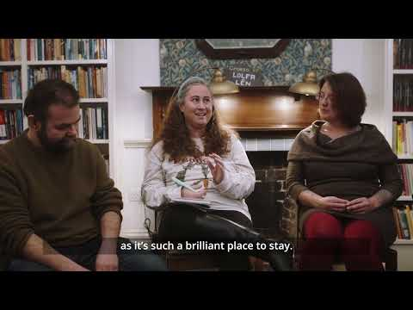
You can find out more about the impact of the Representing Wales programme by heading to the Testimonies section of the project page.

Key Information:

How many places are there on the programme?
There are 14 places on the 2024-25 Representing Wales programme.

How can I apply for this programme?
To apply for this opportunity, we kindly ask that you:
- Read the Frequently Asked Questions
- Send your application via our online application form OR
- Download and complete your application in either a large print or dyslexia-friendly document, and e-mail to post@literaturewales.org.

When will I know if my application was successful?
We anticipate that all applicants will know the outcome of their application by the end of February 2024. Literature Wales is committed to treating each application with the care and consideration it deserves. It takes time for the panel to read and assess every application and for Literature Wales staff to find suitable opportunities and offer specific feedback to each applicant.
You can find out more about the assessment process on our Frequently Asked Questions page.

In what language will this programme be delivered?
Representing Wales is a bilingual programme, and we welcome applications from Wales-based writers who write in Welsh and/or English. Writers who are new to writing in Welsh but who are interested in getting started are very welcome, as are writers who enjoy experimenting with both languages in their creative work.

All events will be delivered through the medium of English or Welsh, depending on the language preference of the cohort. Live interpretation will be on offer where required.
Find out more in our Frequently Asked Questions page.

Why is Literature Wales running this programme?
We know that the sector still presents a range of barriers which prevent writers, readers and audiences accessing literature. Representation and equality are priorities for Literature Wales. Our work aims to help shape a sector that supports equal access for all by addressing historical and structural inequalities and by platforming and developing diverse voices.
Find out more about our Representation and Equality work in our 2022-2025 strategic plan.

Further reading: Why focus on literature from underrepresented writers?
- Literature Wales Strategic Plan (2022-2025)
- Changing the narrative of disability: is representation in books getting better? | Books | The Guardian
- Publishing must make room for disabled authors- for its own good | Books | The Guardian

If you would like to chat to a member of staff before applying, please email Literature Wales at post@literaturewales.or or call us for an informal chat on 01766 522 811 (Tŷ Newydd Office) or you can reach out to us on social media.
Literature Wales staff will also be available to answer your questions during two informal drop-in sessions between 6-7pm on Thursday 24 August and Wednesday 20 September 2023. Click on the dates highlighted to get your free ticket through Eventbrite.

